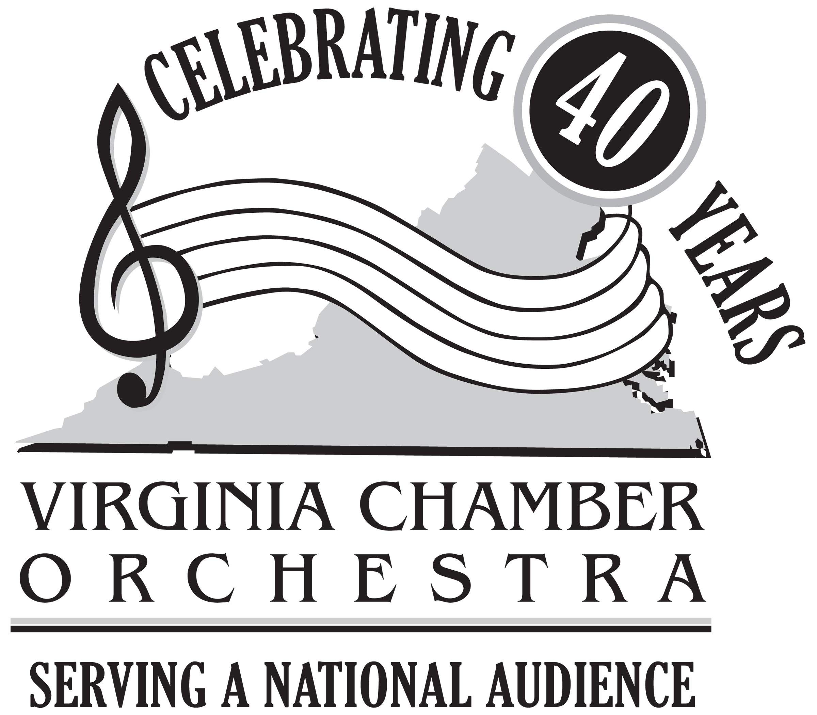
Virginia Chamber Orchestra
Annual Gala & Auction Benefit
Sunday April 3, 2011
Congressional Country Club
Bethesda, Maryland

Auction Donation Contract

We are happy to take part in the VCO Gala Benefit by providing an auction item or gift certificate. We understand our name will be listed in the Gala program if this contract is returned to the address below by March 15, 2011. (For further information, visit the VCO website at: www.virginiachamberorchestra.org)

Company
Name ___________________________________________________Phone ________________________

Address_______________________________________________ email__________________________

City____________________________________________________ State __________Zip_____________

Auction Item/Certificate for: ______________________________________________________________

Description:____________________________________________________________________________

______________________________________________________________________________________

______________________________________________________________________________________

Value: $_____________ Time Restrictions/Expiration Date, if any _______________________________

______________________________________________________________________________________

Donor Contract Name____________________________________________________________________

Donor Contract Signature ______________________________________________Date_______________

Please return Auction Contract and Certificate (if applicable) to:

Petra Kahn, Auction Chair I am enclosing my gift certificate or one
1327 Merrie Ridge Road provided
McLean, VA 22101
703-276-1986 My items need to be picked up. Please call Joan Braitsch at 703-533-3374 to make arrangements

VCO Volunteer ________________________________________ Phone__________________________

