Honorary Board Members
Mrs. Robert Amey
Mrs. Joel T. Broyhill
Mrs. Aliki Bryant
Sondra Jupin Gillice
James P. Goodridge
Marilyn J. Gould
Brigitta C. Gruenther
Mrs. Frederick E. Hart
Mrs. Sophocles A. Hero
Rose Benté Lee
The Honorable Jan Lodal
and Mrs. Lodal
Mrs. Jacques Moore
Sheila A. Mudd
Laurie M. Naylor
Mr. J. Almont Pierce
Mrs. Warren J. Polk
Ms. Lola Reinsch (Pierce)
Mr. Bob Ryan
Gen. Lawrence A. Skantze
Robert R. Spillane
Robin Thurman
Mrs. Kata Trotter
Anne Gregory Vandemark
Robert Goodyear Vandemark
Donna Dixon Wegner

Board of Trustees

Joan H. Braitsch

President
Petra Kahn
Vice President
Martha Child

Secretary
Moner Attwa

Treasurer
Leo Boelhouwer
Paul N. Cantey
Christiana Chiang
Jean V. Chiang
George L. Curley
Betty Farrell
Barbara D. Gholz
Diane Harrison
Charles B. Mudd, Jr.
My-Chau Nguyen
Saundra Pearson
Robert M. Schwaner
Ivan Selig
Ann G. Sica
Charles C. Stringfellow
Jan Tanzer
Fred D. Thompson, Jr.
Patricia M. Woolsey

James M. Lewis
Legal Counsel
Rees Broome, PC

Emil de Cou, Music Director

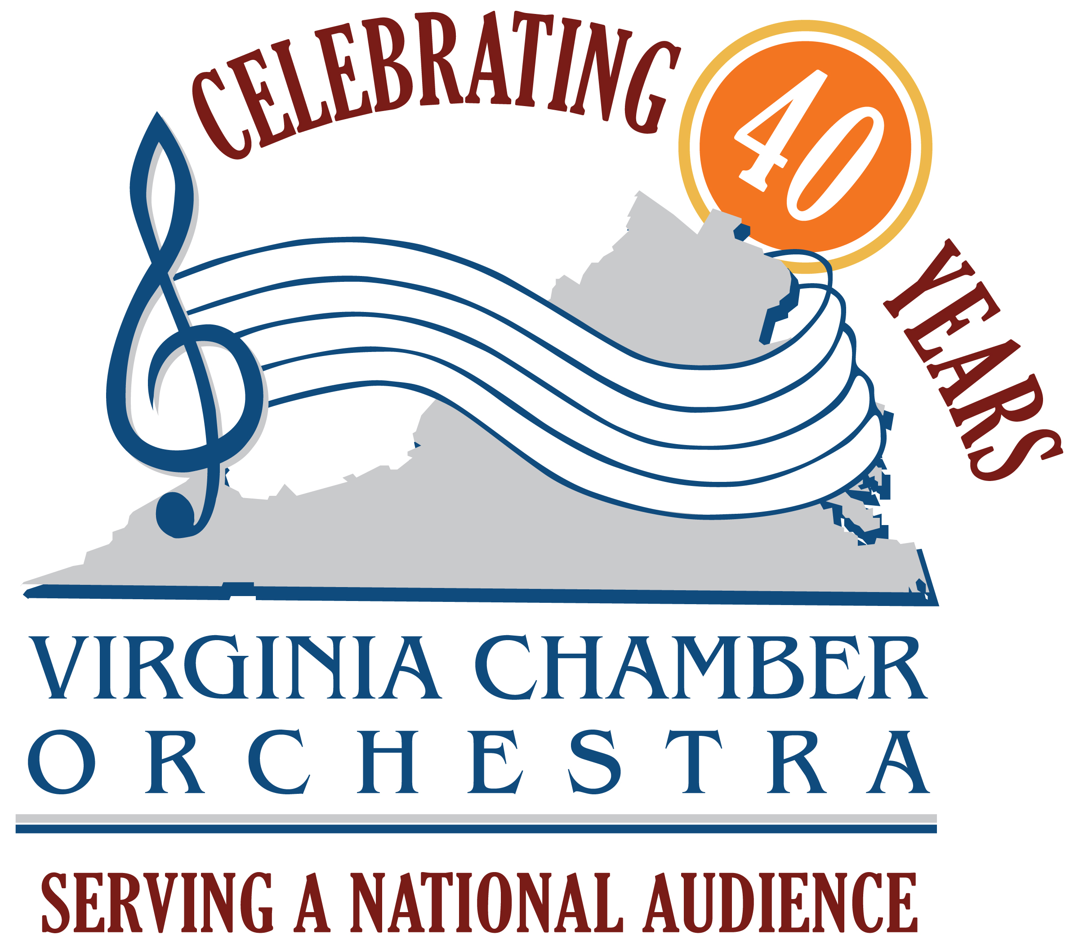

February 3, 2011

Dear Friends of the VCO,

The Virginia Chamber Orchestra (VCO) Annual Benefit Gala Dinner Dance with Live and Silent Auctions is on Sunday, April 3, 2011 at the Congressional Country Club in Bethesda, Maryland. Our theme is Celebrate “The Fabulous Forties" honoring the 40th Anniversary concert season. The Auction Committee, chaired by Petra Kahn and Bob Thompson, is counting on you to donate items or gift certificates as you have so generously done in the past.

Our 2011 Gala Co-Chairs are Bob and Olga Ryan. Bob Ryan is the Channel 7 WJLA meteorologist and a member of the VCO Honorary Board. The

Auction proceeds support VCO’s outstanding live concerts in the Washington Metropolitan area which have received high praise in The Washington Post. Venues include Wolf Trap Farm National Park for the Performing Arts, Constitution Hall, National Presbyterian Church in Washington, DC and Northern Virginia Community College. The Gala also sustains VCO’s Satellite delivered concerts available to millions of students across the country and VCO’s award-winning Special Audience Outreach Philanthropic Program which provides a complimentary dinner and concert experience to selected groups. We are very excited to now offer this opportunity to the Wounded Warriors Project.

The VCO is proud to have Internationally renowned conductor Emil de Cou continue as Music Director. On the east coast, Maestro de Cou conducts the Suzanne Farrell Ballet, the Kennedy Center’s Resident Ballet Company, and will return as NSO @ Wolf Trap Festival Conductor. On the west coast he was named the new Music Director for the Pacific Northwest Ballet this season.

Help us continue the Virginia Chamber Orchestra programs by returning the enclosed auction contract form by March 15, 2011. Enclose your donation with the contract or call to arrange pickup.

On behalf of everyone who has been a recipient of your generosity – anyone who has attended a live VCO concert, listened to a concert via satellite or video streaming, or benefitted from the VCO philanthropic programs –your support and assistance is greatly appreciated. If you have questions, please contact Petra Kahn at 703-522-9161.

Sincerely,
Joan H. Braitsch, President
VCO Board of Trustees

P.O. Box 7484, Alexandria, VA 22307-7484 PH: 703-758-0179
www.virginiachamberorchestra.org
A registered 501 (c) (3) organization

